Turn shoe pattern sizer.

Contents:
- Instructions
- Sizing Sole
- Lace up Slipper
- Low Slipper
- Toggle Shoe
- Sole

Instructions
Apologies in advance that this method of sizing is slightly awkward, one day I will manage to persuade someone to turn some of of this into a computer program that does it for you. Until then this is the best way I’ve got.
- Draw around your foot on a piece of paper. It is best to get another person to do this as you should be standing upright to do it. This is because the foot spreads out more under standing weight than if you are crouched.
- Draw a rectangle around the outline that just touches the edges of the outline. This should be at right angles o the centreline of the sole outline.
- Measure the rectangle along the long and short lines
- Enter these measurements +10-20 mm (this extra centimetre is for seam allowance and can be increased or decreased as you want/need) into the sizing sole sole at the top of this word document that accompanies the PDF. This is done by right clicking and selecting “size and position” you then need to uncheck “lock aspect ratio” and enter the values.
- Take note of the percentages that this has changed the size of the picture by and enter them into all the other pictures in this document.
- You have now sized the patterns to your feet. The patterns have been split into several parts to make them fit on an A4 page so you will need to put them back together using sticky tape to use them. Using the grey lines on the pattern to help you. As with the sizing guide above, one should perfectly cover the other and the pattern will line up.

Sizing Sole
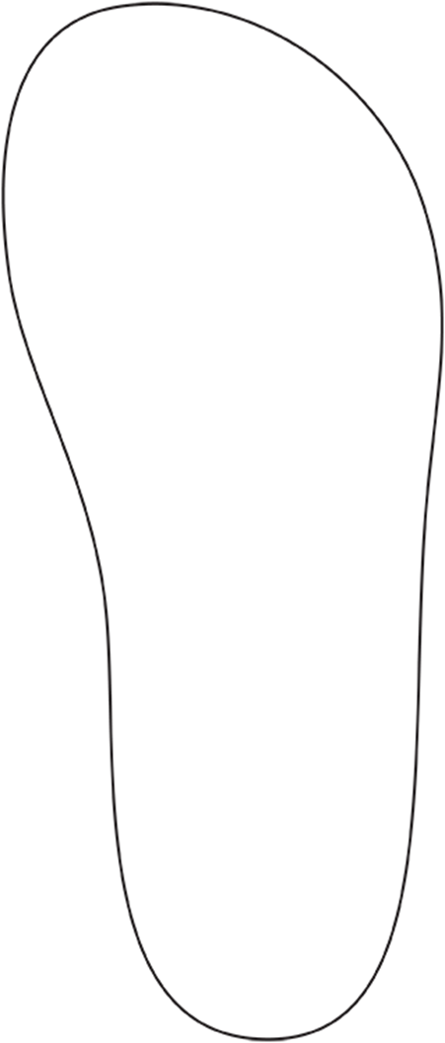

Lace up slipper
Please note that the places that you cut the slits for the single lace (there is no evidence for more than one and it runs around the top of the shoe) are not shown. One on either side of the slit for your foot to go in, one at the back and two in between those two points should suffice though.
IMPORTANT! Do NOT cut the slit for your foot to go into the shoe until you have made the shoe or it will probably go off at a strange angle. The slit on the pattern is Illustrative only.
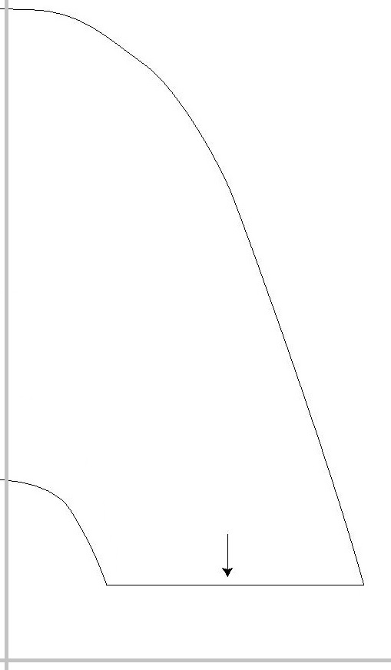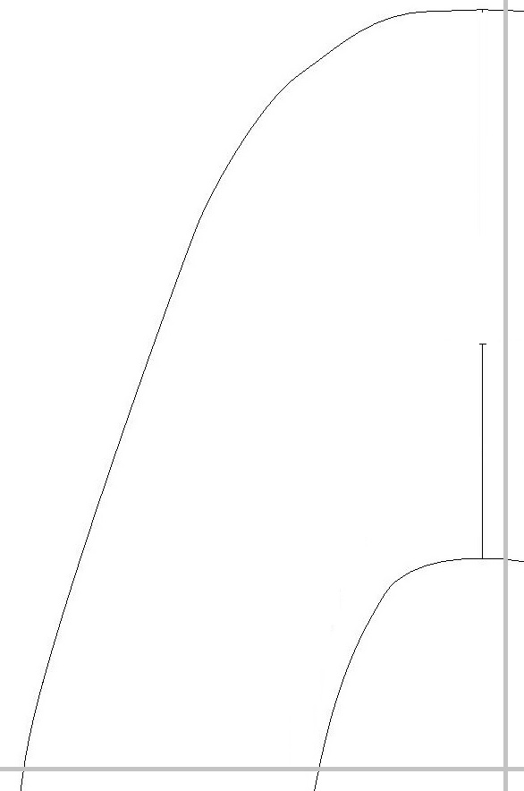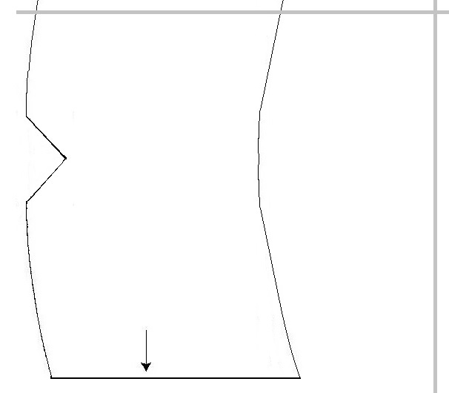

Low Slipper

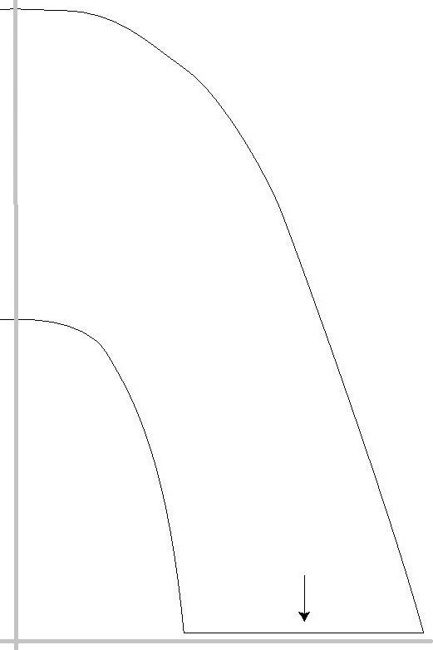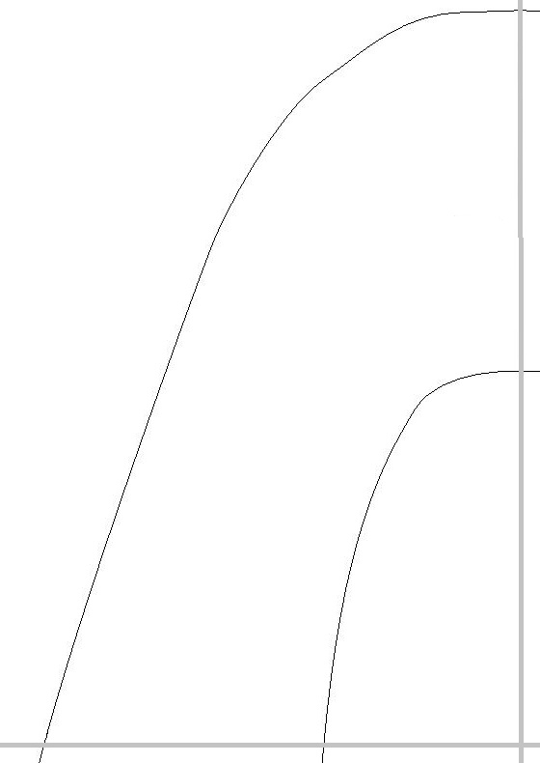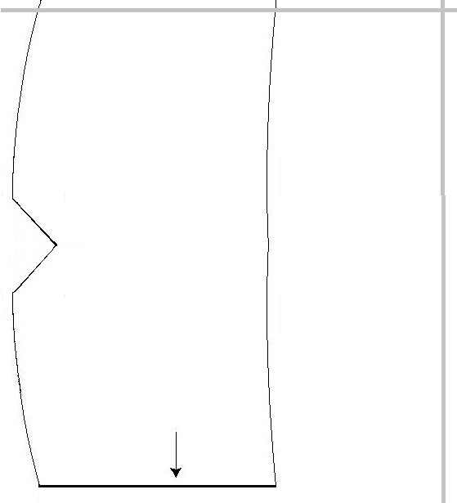

Toggle shoe
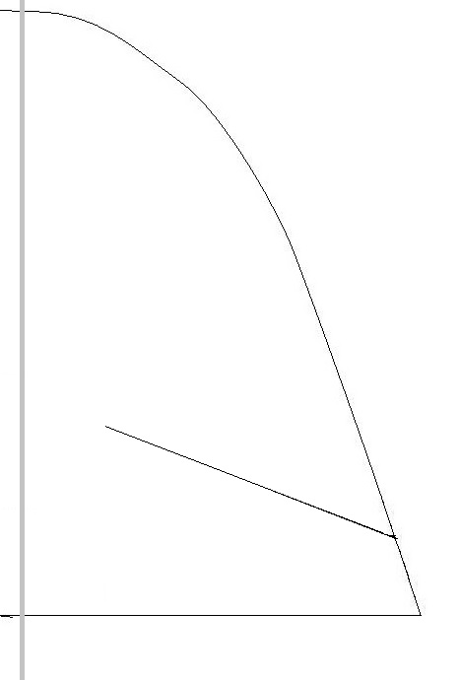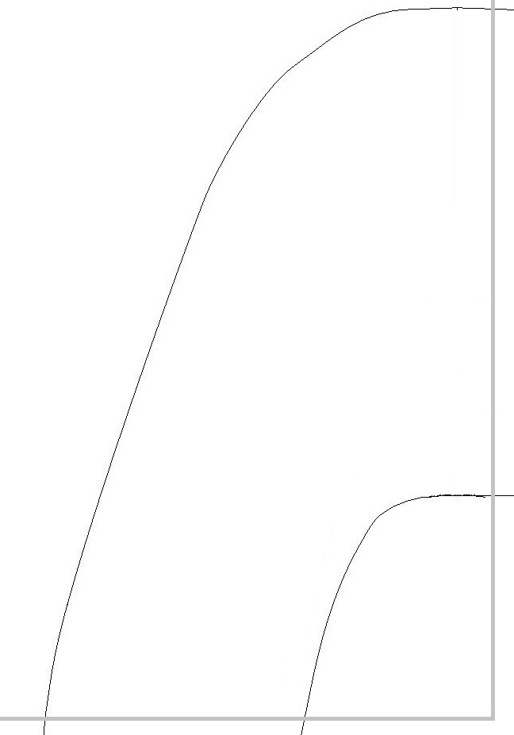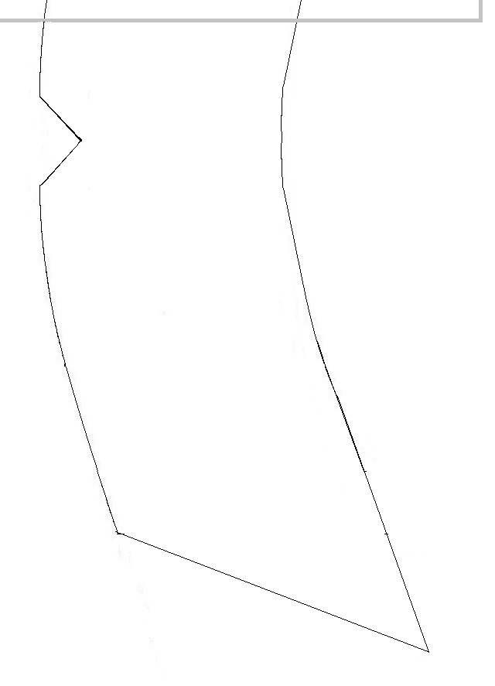

Sole

